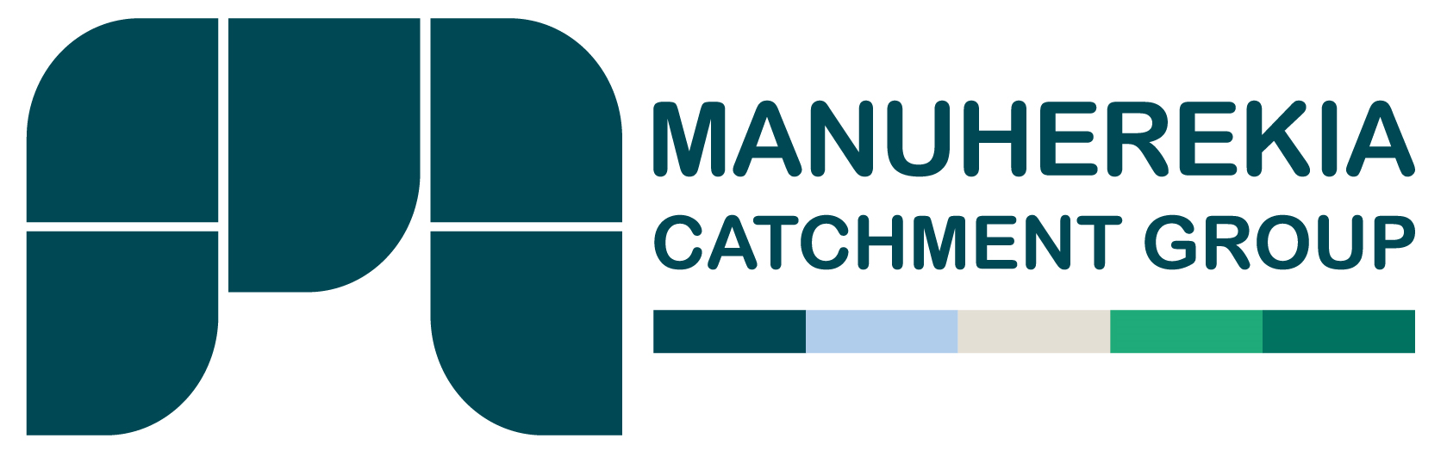

**Membership Form**

Name :

Trading entity:

Membership type (please tick)

**Ordinary Member:** a person or entity who holds at least one numbered current consent issued by the Otago Regional Council to extract irrigation water from the catchments.

**Scheme Shareholder Member**: a person or entity who holds an agreement to take water supplied by an irrigation company or society that holds at least one numbered current consent issued by the Otago Regional Council to extract irrigation water from the catchments;

**Corporate Member:** an irrigation company or society that holds at least one numbered current consent issued by the Otago Regional Council to extract irrigation water from the catchments for the purpose of reticulating water for supply to its shareholders;



**Associate Member:** any person or entity that has an interest in water management within catchments but who does not have a numbered current consent issued by the Otago Regional Council to extract irrigation water from the catchments or an agreement to take water supplied by an irrigation company.

Contact details:

Address:

Phone number:

Water Consent numbers held:

Signature:

**Return by email to the secretary:**

[**manuherikiacatchmentgroup@gmail.com**](mailto:Manuherikiacatchmentgroup@gmail.com)